
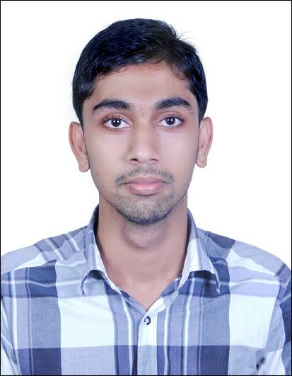
MUHAMMAD PT
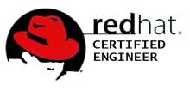
muhammadpt@gmail.com
Contact No: +91-9633267268

EDUCATION:  - B.E. (Computer Science) from Anjuman Institute of Technology and Management, Bhatkal in July 2014(58.17%)  - Secondary Education from MIM Higher Secondary School, Nadapuram under Higher Secondary Board of Education, Kerala 2010(76.36%)  - Matriculation from MIM Higher Secondary School, Perode in 2008 (88%) | CAREER OBJECTIVE:
 | Seeking a position to utilize my skills and abilities in the Information Technology Industry that offers Professional growth while being resourceful, innovative and flexible.
 | CAREER SUMMARY:
 | 1.3 Years of Experience as System Administrator in different Domains

CERTIFICATION
- CISCO CERTIFIED NETWORK ASSOCIATE(Jan.07,2017) Cisco ID: CSCO13110841
- RED HAT CERTIFIED ENGINEER (Red Hat Enterprise Linux 6) - Oct. 15, 2014.
Certificate Number: 140-197-583
- A+, N+

PROFESSIONAL EXPERIENCE

1 | Ginnovee Technologies Pvt Ltd  Role : System Administrator | Duration: Feb 2016 to June 2016
1 | Description: System Administrator in Telecom Services
1 | Responsibilities:  - Work with IBM X Series Servers using Red hat Linux  - Ensure the connectivity between the Servers.  - Maintain Server to be available 24/7 hours to Customer.  - Regularly monitor services and manage process load.  - Provide Quick Support to customer for their open calls regarding Services and Back office issues.  - Co – ordinate with Team for Updates and Daily Report.  - Install and Configure Tools as per the customer request.  - Troubleshoot and solve the services related issues.  - Resolve the back office customer care issues of Sabafone, YMobile, Yemen Mobile

2 | Life Insurance Corporation of India EDMS Project- Goa  Role : Linux System Administrator (EDMS Project) | Duration: October 2014 to October 2015
2 | Description: Enterprise Document Management System
2 | Responsibilities:  - Work with HP Proliant Servers Using Red Hat Linux 4.4 Customized Versions.  - Ensure the connectivity between branch EDMS Servers and Division EDMS Server.  - Maintain Server to be available 24/7 hrs to Customer.  - Regularly monitor services and manage process load.  - Provide Quick Support to customer for their open calls regarding EDMS Servers.  - Co – ordinate with Team for Project Updates and Daily Report.  - Upgrade Server and the Utilities Installed in the Server by using Hot Fixes and Patches released by Software Vender.  - Take Weekly and Quarterly Backup of Server Using HP’s Utility on Tape Drives and HDD.  - Upload Client Data on Division and Branch Servers Using Upload Utility.  - Prepare Upload Reports and Signoff Certificates of Uploaded Data for further transactions.  - Manage Preventive Maintenance of Division and Branch EDMS Servers.  - Carryout Weekly Housekeeping Activity of EDMS Server e.g.: Vacuuming Re-Indexing etc.  - Operations on Postgresql Database

TECHNICAL SKILLS
LINUX SKILLS
- Installation of Different Linux Flavors
- Working knowledge on different Linux Distros
- Troubleshooting operating system failure
- Sound knowledge about Logical Volume Management.
- Configuring Postfix, SMTP mail Servers.
- Configuring APACHE web server with SSL Support.
- Server Configuration – FTP, NFS, DNS, DHCP, SMTP, SAMBA, NTP, Yum Server and Client using different ways.
- Installation of Linux through different methods using KICK START, network services like HTTP, FTP and NFS.
- Creating users and assigning rights to profiles, home directories.
- Backup scheduling and monitoring using utility on Linux and Windows Platforms.
- Backup and Restore through Tape Drive, HDD, DVD and Removable Devices.
- Configuring Nagios and monitoring the infrastructure
- Configuring SVN
- Configuring and managing Asterisk
- Fundamental Kernel programming
PROGRAMMING SKILLS
- Python ,Bash Scripting ,C, SQL

NETWORK SKILLS
- Installation and setup of routers and switches
- Responsible for troubleshooting of networking equipment across multiple sites
- Full Command on Cisco IOS Commands
- Router IOS Backup and Recovery
- Setting up Serial and Ethernet Interfaces
- Routing Protocol Configurations
- Full Command in Inter-VLAN Routing
- Switching, Standard Access-list, Extended Access-list and Vlans Configurations.
- Sound knowledge of OSI 7 Layer Model, TCP/IP, DNS, DHCP, TFTP.
- Knowledge of LAN technologies, Switches, Cables, Bridges
- Good working knowledge of routing protocols such as RIP V1/V2, OSPF, IGRP and EIGRP
- Experience of IP addressing, administrating subnets and various routing models
- Familiar with the setup and basic configuration of Cisco 2950, 2960 Switches
- Implementation of DHCP, DNS, FTP, TFTP, MRTG.
- Design and implementation of LAN/WAN, using Cisco routers, hubs and switches

DESKTOP SKILLS
- Installing and troubleshooting Operating Software such as Windows 10/Win7/Vista/XP/98&Red-Hat Linux
- Assemble & Disassemble Hardware Components and Troubleshooting

LANGUAGE SKILLS
Language | Read | Write | Speak
Malayalam | Fluent | Fluent | Fluent
English | Fluent | Fluent | Fluent
Hindi | Moderate | Moderate | Moderate
Arabic | Fluent | Fluent | Beginner

PERSONAL STRENGHTH

- Ability to work independently with limited supervision.
- Individual contributor with strong analytical and problem solving skills
- Creative, Logical, Keen observer and Problem Solving ability.
- Committed to deadlines and schedules

ACHIEVEMENTS
• Achieved First Prize in Hardware Assembling NEBULUS'11 at AITM Bhatkal
• Worked for National Level Tech Fest NEBULUS'14 at AITM Bhatkal

PERSONAL DETAILS
Date of birth: 07/12/1992
Gender & Marital: Male & Single
Nationality: Indian
Passport No: J7633127
Hobbies: Travelling, Reading, Music
Permanent Address: Thayyullathil (H)
Puliyavu(PO)
Kozhikode
Kerala
India
673509
Declaration: I declare that the details furnished here are true to the best of my knowledge
With Regards,

Muhammad P T

